**What is ServiceNow**

According to Jeff from ServiceNow Simple, ServiceNow is a technology firm that offers a cloud-based platform for businesses to manage their IT services.

The company was founded by Fred Luddy in 2003. Fred Luddy was inspired to create ServiceNow due to his dissatisfaction with the inefficiencies he saw in conventional IT departments.

Jeff explained that the ServiceNow platform leverages cloud technology to provide a comprehensive suite of applications, platforms, and infrastructure needed to meet various business IT requirements.

He also noted that ServiceNow is based in Santa Clara, California, and has a global workforce distributed around the world.

**ServiceNow Platform Overview**

In a video interview with Fred Luddy, the visionary behind ServiceNow, he offers a brief insight into the origins of the company. Established in 2004, ServiceNow was designed to help businesses tackle technological challenges. By 2021, Luddy, who left college early, had accumulated a net worth of $1.3 billion.

The video then delves into the specifics of the ServiceNow platform, describing it as an application Platform-as-a-Service (aPaaS) solution. This sets it apart from other cloud models such as Infrastructure-as-a-Service (IaaS) and Platform-as-a-Service (PaaS). What makes ServiceNow distinct is its reliance on a unified database and comprehensive data models that cater to a wide range of business functions.

The presentation also covers the various applications and workflows provided by ServiceNow, which are organized into four main categories: IT workflows, employee workflows, customer workflows, and partner workflows. Each category includes several subcategories and specialized applications.

Lastly, the video outlines the architectural design of the ServiceNow platform. It operates on a multi-instance framework, where each client has their own dedicated instance. This setup ensures enhanced flexibility and control for larger organizations. The video also highlights the platform’s features related to availability and redundancy.

**ServiceNow User Interface Overview**

This is the third module of the ServiceNow Fundamentals Learning Plan: ServiceNow User Interface. The aim of this session is to familiarize trainees with the layout of the UI, locations of elements, and tools available within a UI used most in a UI, such as the user menu, global search, connect chat, contextual help, system preferences, application navigator, favorites, and browsing history. The video opens with a brief review of some important notes, like a cheat sheet for certification exam preparation, before diving into the specifics of the different ServiceNow user interface elements.

Overview of Previous Lessons:

Lesson 1: Introduction to ServiceNow

• Purpose and Scope: ServiceNow is a cloud-based platform developed for aiding different organizations in the management of IT operations and service delivery. The lesson evaluates how ServiceNow can be used in automating IT processes to improve efficiency.

• Company Background: The section gives a good history of ServiceNow, starting from its establishment and further development over time. It involves reflections that consider how the vision, mission, and individual methodology of the company impact IT service management.

• latform Essentials: This module focuses on incident management, problem management, change and asset management, and parts of the service catalog in ServiceNow. Flexibility, extensibility, and integration possibilities of the platform with other systems will also be checked in this module.

• Applications and Workflows: This section deals with the numerous applications that exist within ServiceNow, along with their supporting workflows. It focuses on how these applications increase business processes relating to human resources, facilities management, and customer service, and explains how workflows can be customized for an organization's preference.

• Platform Architecture: This section provides an overview of ServiceNow's cloud-centric infrastructure and multi-instance framework. Moreover, it talks about the attributes of the platform concerning scalability, reliability, and security. 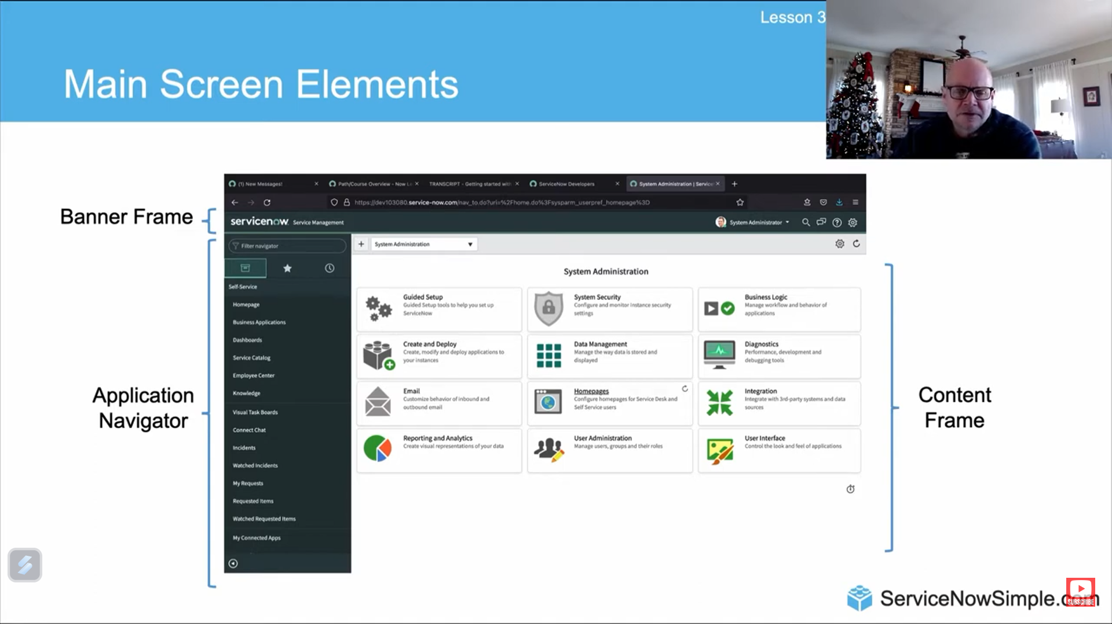

Lesson 2: ServiceNow User Interface Overview

• Configuration of the ServiceNow User Interface: This module covers basic configuration of the ServiceNow interface, including the navigation menu, header, and primary content area. It contains activities that help a user navigate through multiple pages and applications on the platform.

• Interface Components: This instructional session presents the diverse elements constituting the ServiceNow user interface, including forms, lists, and charts. It elucidates the methods for engaging with these components, encompassing the creation and modification of records as well as the filtration of data.

• Instruments: The learning content focuses on major instruments at one's disposal within the user interface of ServiceNow, such as the User menu, Global Search functionality, Connect chat, Contextual Help, Set-up, Application Navigator, Favorite list, and History list. It explains their purposes and how to use them effectively for increased productivity and operational efficiency.

**ServiceNow Branding Overview**

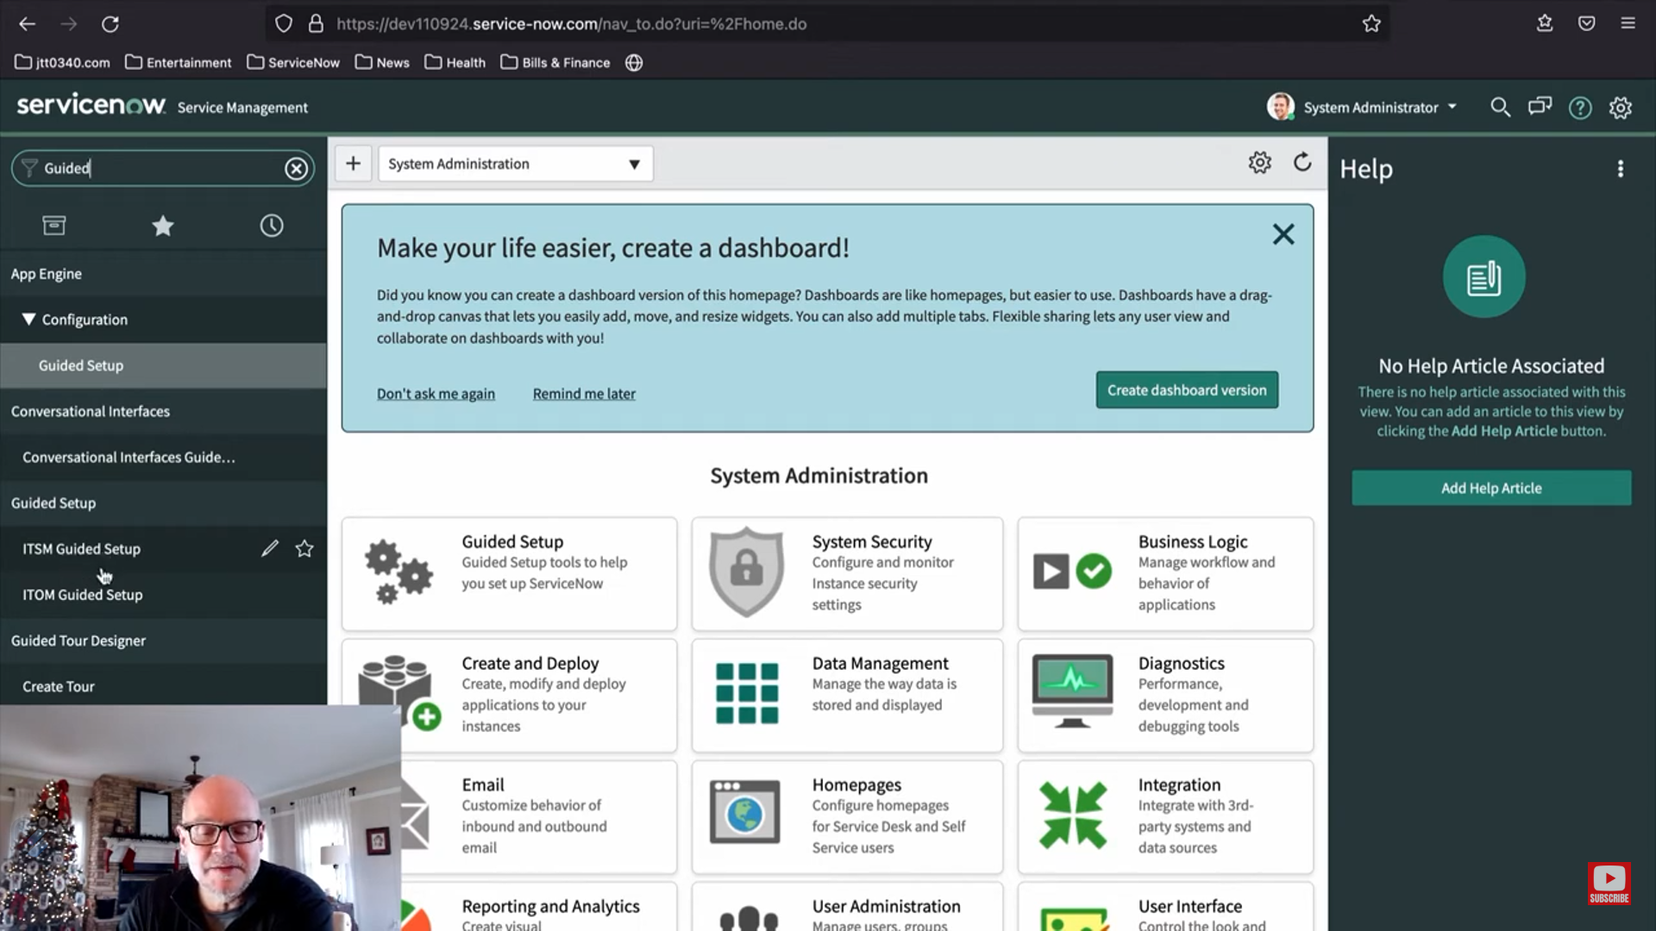

In this fourth module of the ServiceNow Fundamentals Learning Path, we take time to understand more about ServiceNow branding and its role within the platform.

Understanding ServiceNow Branding

ServiceNow branding refers to the individual organizational identity for the user interface of the ServiceNow platform. This might include organizational logos, font choices, and/or a corporate color scheme. This sort of branding is crucial for making the platform feel like an extension to the organization's own systems, thus creating familiarity and consistency in the user experience.

Why do brand in ServiceNow?

ServiceNow branding allows for better user engagement by aligning the appearance of the platform with the organizational brand already established. Users would feel more at ease and connected because the look and feel of the platform ring familiar with the organizational environment already well-known. Effective branding will increase user adoption and overall satisfaction with the tool.

Key Branding Features in ServiceNow

• Guided Setup: The function describes the sequence of setup needed for configuration by an application or module in ServiceNow. It guides the user to apply branding elements, ensuring that customizations are applied correctly.

• ServiceNow Portal: ServiceNow Portal has flexible branding. It allows interface design using a widget-based approach. A user is at liberty to drag about face widgets to customize the layout and appearance of the portal, making it meet a company's branding.

• UI Builder: Basically, it works like a WYSIWYG editor that allows users to create custom pages and screens. It's extensible; additional interface functionality, for example, buttons or headings, can be added to let the user customize the interface according to his branding needs.

**ServiceNow Lists and Filters**

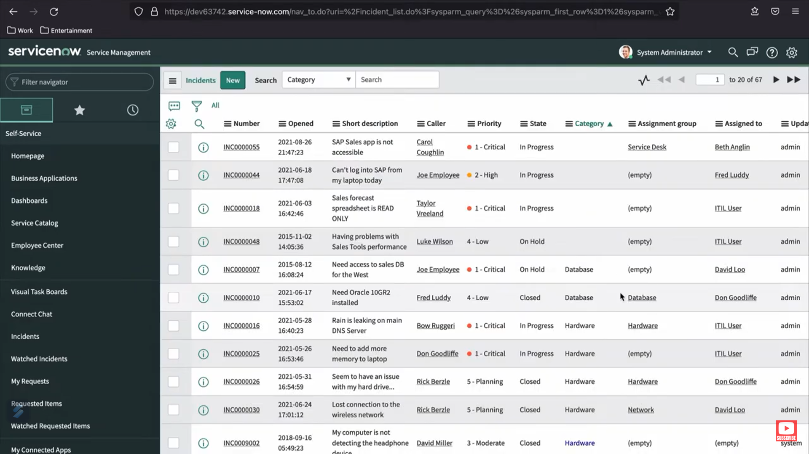

In the instructional video of ServiceNow Simple, much attention is given to the building blocks responsible for retrieving data and analyzing data in ServiceNow: lists and filters. The video starts with explaining what a list view is: it is a system-generated page view for any set of records from a database table in ServiceNow. Every list view is strictly related to one table, which offers users the possibility to work with this data by way of sorting, searching, filtering, and examining.  
• Users can view lists through the Application Navigator or by entering a list command which includes a period following the name of the table. For example, typing the name of a table and appending ".list" will automatically launch the corresponding list view. The sys_db_object table is used to track all tables within the ServiceNow database.  
Each list view comprises a number of key elements. The title bar includes the List Control menu, by which users are able to apply saved views, organize data, decide upon how many records per page, and refresh the list. It also contains a Search field for finding particular values, with an icon for an Activity Stream documenting all actions related to the list. The List Header also includes a number of additional useful tools, such as the Customized Lists Tool for column manipulation, Condition Builder for applying filters, and MultiColumn Search for searching in multiple columns at the same time. Breadcrumbs will appear for applied filters. Column Context Menu has options to create charts or set up some advanced settings.  
• Other actions provided by the Column Context Menu include record filtration, copying of URLs or System IDs, and the ability to tag and update rows for list items. Generally, this structured consistency is carried through into the list views in ServiceNow to give overall consistent user interactions when working with lists

**Forms in ServiceNow**

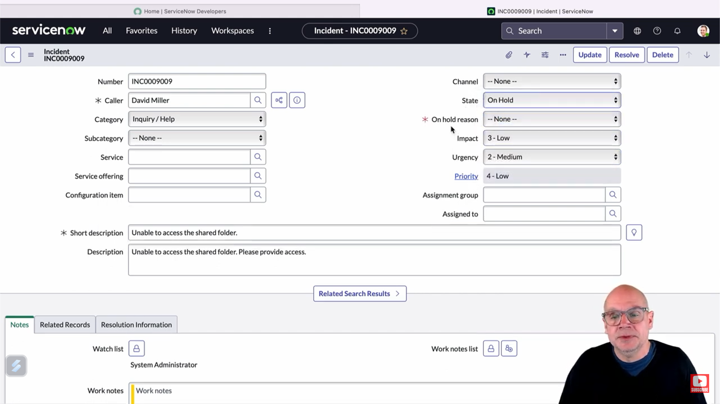

Forms are the main building blocks in ServiceNow that allow users to display, update, and alter record data. There is a form configuration for each type of record that includes a header section, main content section in the middle, and additional sections. The header section contains an assigned form name, a contextual menu for navigation among the various form settings and configurations, and the Options button for access to various templates and additional settings.

The principal section of the form comprises various fields that are designed to record and present the characteristics of the entry. These fields are classified into distinct categories: text fields accommodate string data, checkboxes serve for Boolean representations, dropdown menus facilitate selection of options, reference fields enable connections to additional records, multi-select lists permit the selection of numerous choices, and journal fields are utilized for recording entries or remarks.

Other elements which can be added to a form include sub-forms, such as the Related Records subsection, drawing data from the related tables. Formatter elements can also be added that may make detail information appear, such as activity logs or attached files. Buttons to store changed forms or create new records are Save, Submit, Update, Insert, and Insert-and-Stay.

• The form sections are helpful in organizing numerous fields into meaningful groups for managing complex data easily. To make it more self-configurable, the form customization tool assists in adding, deleting, or rearranging fields in any form. One can attach relevant files from within the form using the 'manage attachments' button.

Furthermore, one can use form templates to prefill certain fields with values previously set up to enable record creation in an automated manner. It also has design and layout tools to change form layouts and views, offering flexibility in how the forms may be presented and interacted with.

ServiceNow forms are agile living things that permit data administration and individual customizations, hence improving the functionality and experience of the whole platform.

**A Hands-on ServiceNow Tool Demo**

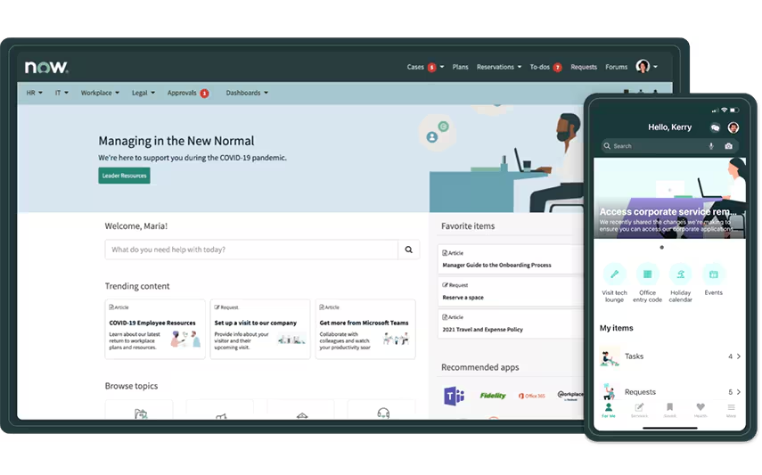

• This presentation focuses on the platform of ServiceNow, outlining its features and capabilities. At the beginning of the session, there is an introduction of ServiceNow—how it works—followed by a live demo of the tool in action.

• ServiceNow can be used after logging in to an account that has a unique URL. The components of the ServiceNow interface are the navigation bar, contextual application tab, universal navigation, global search, user menu, contextual help, application scope selector, workspaces, history, favorites, and menu.

By default, the "All Menu" in ServiceNow displays all available applications within the platform. ServiceNow knowledge management features allow one to author and publish knowledge articles, hence effectively sharing and managing information.

It also provides an illustration of how to fetch data from ServiceNow's database and how to request a personal developer instance for personal use.

**Introduction to Importing Data in ServiceNow**

The process of importing data into ServiceNow via integrations encompasses several essential steps to guarantee a seamless and precise data transfer procedure:  
• Identify Source of Data: Begin by identifying the source of the data that is to be imported. This includes identification and configuration of the source itself from which the data will be extracted.  
• Import Set: One must create an import set, which acts as a staging area. The set provides a one-to-one relationship between source data and its target staging table used for storing the data initially received for further processing.  
• Build a Transformation Map: Build a transformation map, consisting of rules on how data should be transformed as part of the import. This is tantamount for mapping and transforming the data to a format consumable by ServiceNow.  
• Design a Field Map: Create a field map so that the fields in the staging table can be matched with the corresponding fields in the target data repository. This approach assures that each piece of data is correctly matched and delivered to the corresponding field in the final destination.  
• Plan the Data Import: Plan and schedule the running time of the data import. This comprises setting the schedule and recurrence for data transfers in a manner that ensures seamless, on-interval execution.

**Creating a Data Source in ServiceNow**

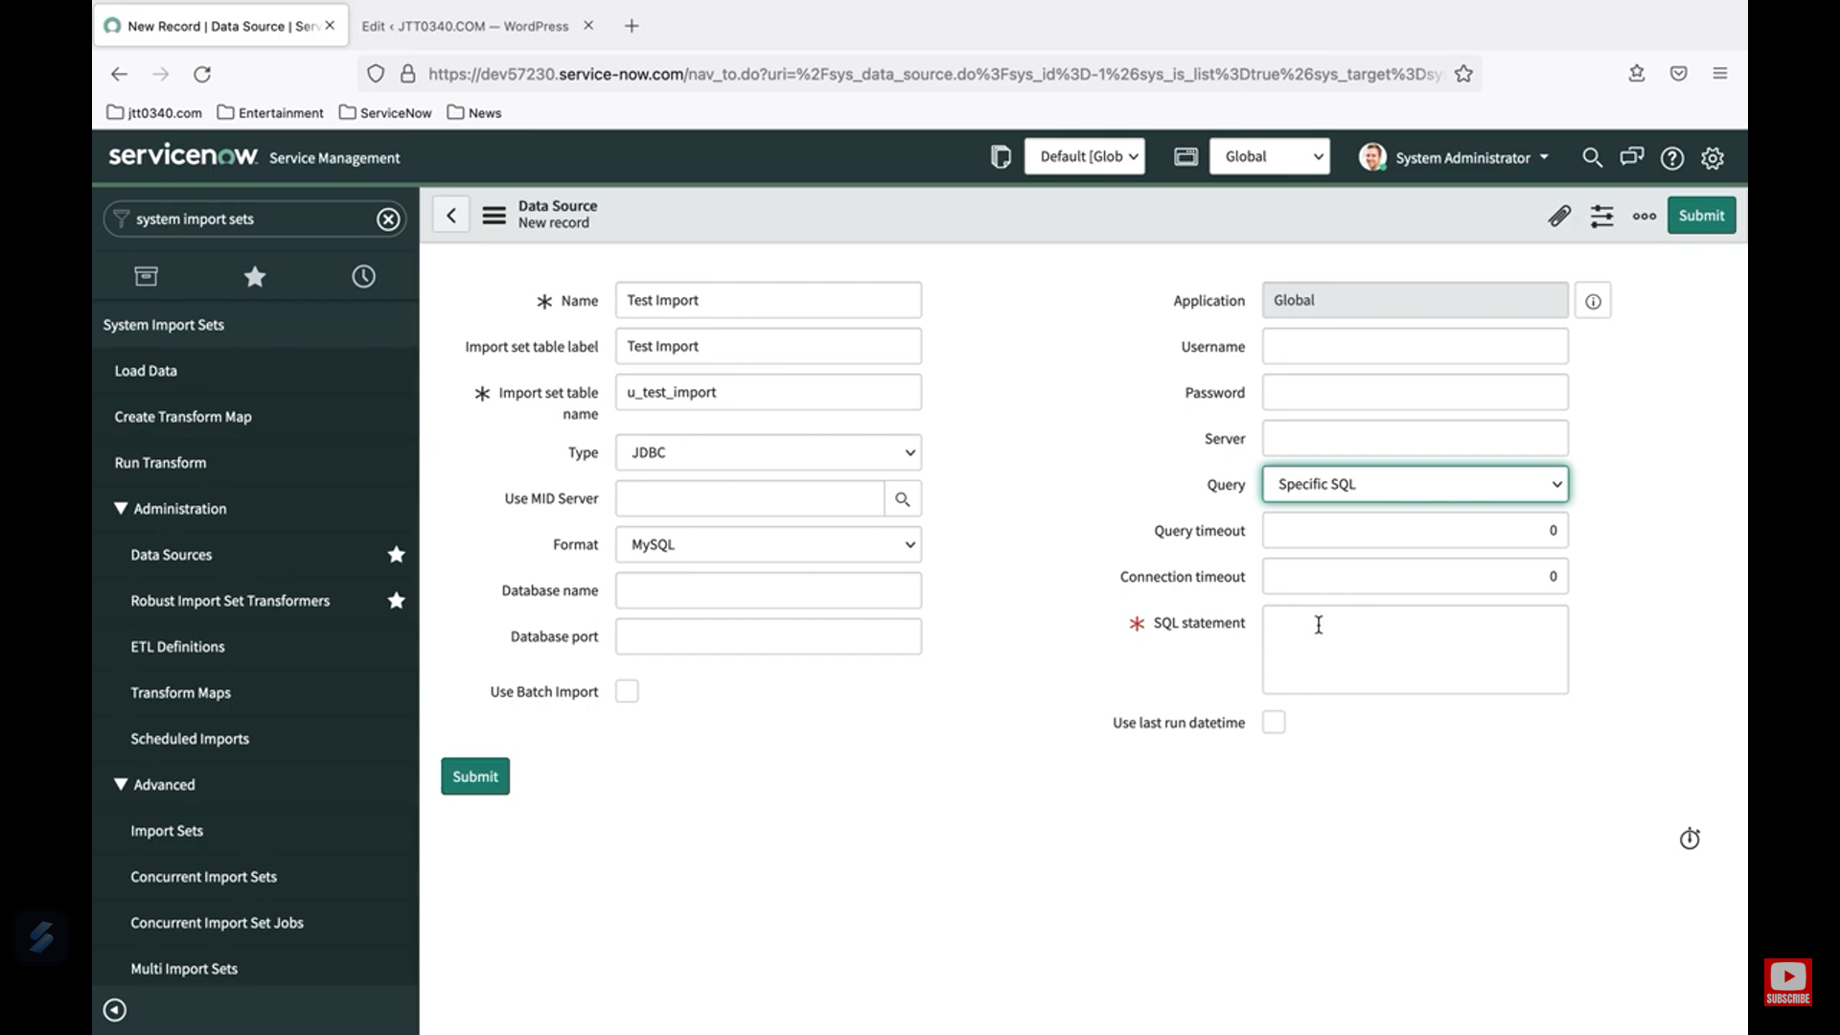

A data source in ServiceNow defines the origin of the data to be imported, as well as the type of the source, the location of data, and authentication credentials.

•To configure a data source in ServiceNow, follow these steps:

• Access Data Sources: Go to System Import Sets > Administration > Data Sources.

• New Data Source: Start off the definition of a new data source using the 'New' button.

• Identify the Data Source: A descriptive name should be entered in the Name field. This will create a reference name for use within ServiceNow.

•Data Source Type Specification: Enter the description of the data source type for which you are configuring. Available options are:

•File

•JDBC

•LDAP

•OIDC

•REST

•Personalized Script

• Complete Additional Fields: Fill in extra fields accurately based on the chosen data source type. Additional fields may vary depending on the selected type and the required configuration parameters.

• Save the Data Source: Select the Submit button to create the data source and maintain it in ServiceNow.

**Understanding Import Sets in ServiceNow**

Using Import Sets in ServiceNow starts with looking at a data source record. This record outlines parameters, such as the label and the name of the table used for the staging table. When data is imported into ServiceNow, this parameters are used to create the staging table.

• The import process involves some key steps. First, it checks for a staging table, and if none exists, ServiceNow creates the table, connects to the data source, and moves the data into the newly created staging table. The video confirms that the staging table was successfully created with the proper name and label; the data has been successfully transferred.

The video then goes on to discuss another major part of what ServiceNow can do: the import set table. An import set record is a grouping of records together in a staging table after an import job. Each record in the staging table is related to its own import set record, and through these ways, ServiceNow is able to handle and monitor information brought in from several different import jobs.

This video summarized the process of what is to be covered: Create your data source record, Test your data source and import process, Understand your staging table, and Manage your import set table. The next step in the process is configuring how the data is mapped and loaded into the ServiceNow target table from your staging table.

**ServiceNow Transform Maps & Field Maps**

The import procedure in ServiceNow comprises, first of all, the creation and validation of a data source; the data is then transferred into some kind of intermediary table known as the staging table.

• Field Mapping and Transformation Mapping:

Field mapping is required to indicate which fields of the staging table are to correspond with which field of the final target table. For instance, "name" on the staging table might correspond to "username" on the final destination table. This mapping ensures the exact delivery of data from the staging table to the target table.

Transformation maps are important in putting the many-to-many field mappings into place in a collective strategy for the overall import process. This structured approach provides assurance for data integrity and consistency throughout the whole process of import.

• Customizing Tables:

In addition, the guide explains how to create custom tables in ServiceNow, in which the imported data will be stored. The planning involves designing fields in the custom table which will mimic the configuration of the data to be imported, therefore accommodating proper organization and management of data.

• Building Field and Transformation Mapping:

The tutorial explains how to create field maps, such that it links fields from the staging table to their equivalents in the target table. It goes further to describe how the field maps are arranged to be a transformation map so that it will be a systematic guide on data importation.

•Employing Coalesce Fields:

Coalesce fields are utilized to check if any records will result in duplication during the import operation. With a coalesce field selected—like "name" perhaps—ServiceNow checks existing records to see if it has a matching record, and if it does, the system prevents a new record from being created to protect its integrity.

•Final Steps and Verification:

Once the transformation map and the field mappings have been configured, the video describes how to finalize the process. This includes the important step of testing to ensure the source table data is being correctly transferred to the target table. Finally, it suggests that imports be scheduled for future data transfers, thus allowing for data management to occur automatically. This comprehensive tutorial will help any user manage data import processes in ServiceNow.

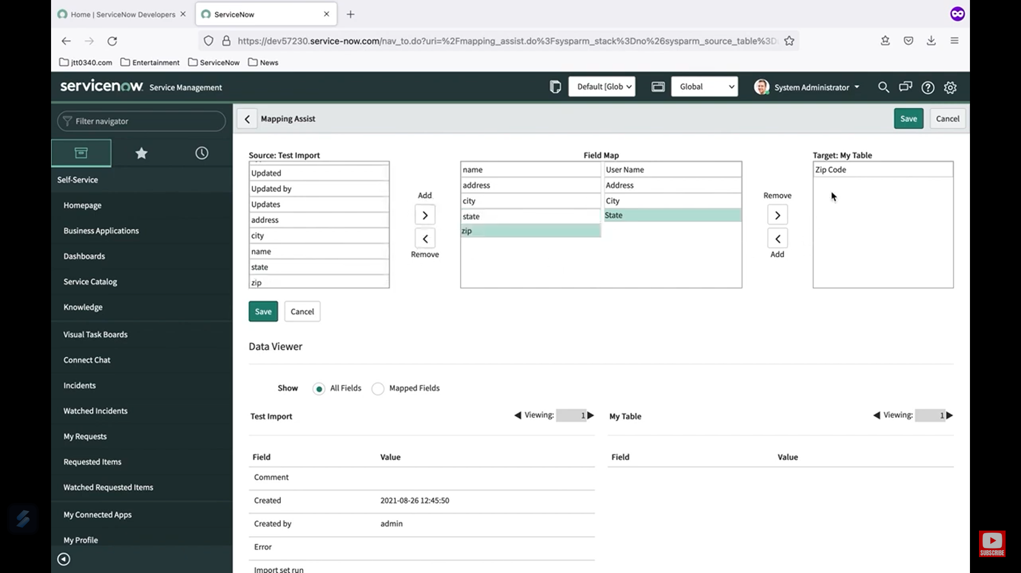

**ServiceNow Incident Management and Task Administration Tutorial**

ServiceNow task management is primarily based on the table of task records that functions as the foundation for a variety of related task capabilities. Thus, incidents, changes, and problems are all built upon this core task table, meaning that they inherit and extend the core attributes and design provided by the task table.

•Task Creation and Management:

This tutorial will start with the overall structure on how tasks are organized within ServiceNow. It explains the hierarchy of tasks involved in creating and managing incidents, change requests, and problems within the system; all tasks will be dealt with in a systematic and tracked way throughout their lifecycle.

•Task Assignment Rules:

Then, it introduces the rules of assignment, in which tasks will be automatically assigned to the right user or group, depending on the defining criteria. Detailed steps in creating the rule, its configuration settings to filter and distribute tasks, and verification that tasks are issued to the right person or group in relation to predefined criteria are included.

•Task Coordination Tools:

The video further examines the collaboration tools offered by ServiceNow, which facilitate improved task coordination. Attributes such as user presence indicators and real-time editing capabilities enable numerous users to concurrently engage in task-related activities, thereby enhancing both collaboration and efficiency.

•Visual Task Boards:

It finally covers visual task boards, which refers to the visual way of managing and organizing tasks. The user can use different kinds of task boards, like guided, flexible, and freeform, to track and manage tasks using drag-and-drop. The section describes how visual task boards can be used to track effective task progress and manage the overall process.

This lengthy manual is a close look at task management in ServiceNow, focused on create, assign, coordinate, and visualize.

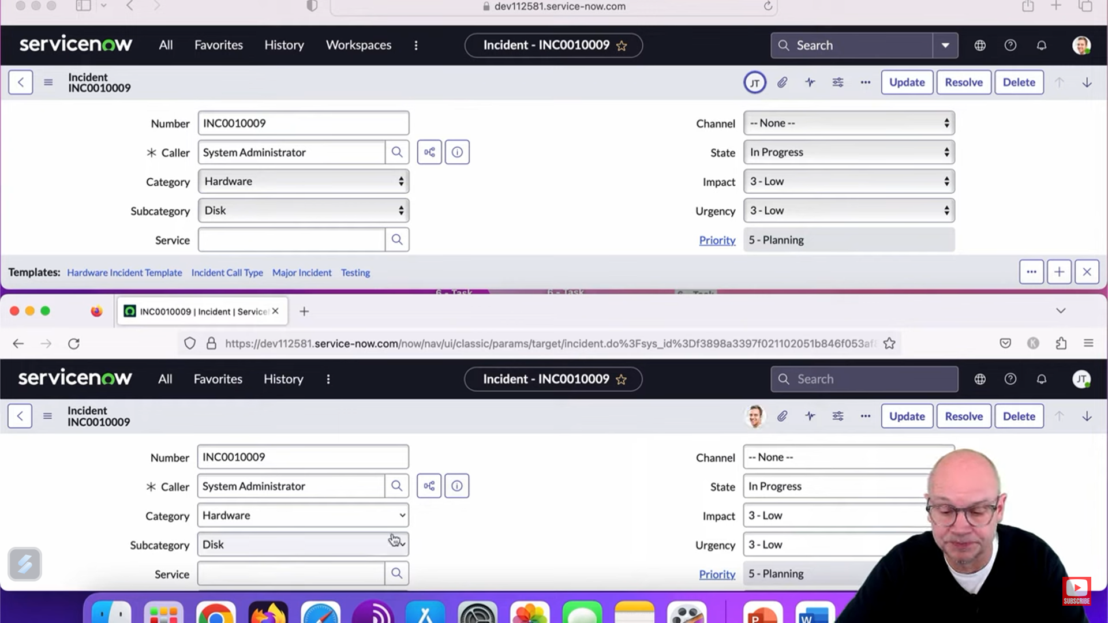

**ServiceNow Reporting Tutorial**

Foremost in the ServiceNow tutorial is understanding that everything one glimpses reflects some record in its database. This understanding is very key to effective reporting in the platform.  
  
Understanding the Report Table and Data Model:  
  
The real heart of reporting within ServiceNow is the sys_report table which forms the container for each saved report expressed as a stand-alone record. There are a few associated tables that extend this reporting functionality:  
Report Source Table: This contains pre-defined queries which can be used with several reports, defining ways of obtaining data.  
Scheduled Email Reports Table – ability to generate reports and have them mailed automatically to specified users/groups at a pre-defined time.  
Users and Groups Table for Reporting: Manages report access, allowing designated users or groups to receive and execute reports.  
Dashboard Table: Bringing reports and dashboards together, showing large views of data when combined with other widgets.  
Report Creation:  
  
The tutorial is a guide showing all steps to create a new report. Reports can be started from the "Create New" module of the Reports application, ServiceNow Studio, or directly from the data list view.  
  
Most critical components in report making include:  
  
Names The title of the report.  
Source Type: indicates whether the report is table-based or pointed to a specific source.  
Table: It specifies from which database table data is to be fetched.  
Group By Field: This is a required field to group data intelligently for meaningful display.  
  
It can be developed into a variety of types of visualizations: pie charts, bar charts, line charts, histograms, and heat maps—all adapted to fit the most convenient way of representing data.  
  
Report Management:  
  
Other various properties that may be set during the process of managing reports include filter, grouping fields, and format attributes. Such properties are important to be understood toward making sure that the reports are represented optimally with the maximum possible data representation while formatted most meaningfully.  
  
Schedule Reports:  
  
The tutorial will also show how to schedule reports to run automatically at periodic intervals, such as daily, weekly, or monthly. A schedule can be created by selecting the report view, recipients, and specifying when the report should be sent and in what format, like a PDF or Excel document. Options are provided to customize email content.  
  
Sharing Reports  
Sharing of reports is necessary for collaboration. Reports can be shared with individual users, groups, or the public. The tutorial describes how access control is managed by manipulating entries in the Report Users and Groups table to allow certain people to view/run reports.  
  
Add Reports to Dashboards  
  
Dashboards can merge reports within a single view for multiple metrics of data. This tutorial will walk through adding reports to pre-existing dashboards, guided by choosing the correct dashboard and tab, and integrating other widgets and tools of analytics for a broad overview of data.  
  
Improved Features: For advanced users, the tutorial covers the following features: Conditional Execution: Conditions on which reports can be made to run can be scripted in their settings in the Scheduling Framework. Advanced customization options allow both the appearance and settings to be changed to show exactly what a user means. The following step-by-step tutorial will guide users through the necessary knowledge of how to successfully create, manage, schedule, and share, along with report enhancements in ServiceNow. Implementing these reports into dashboards provides a seamless experience in data analysis. 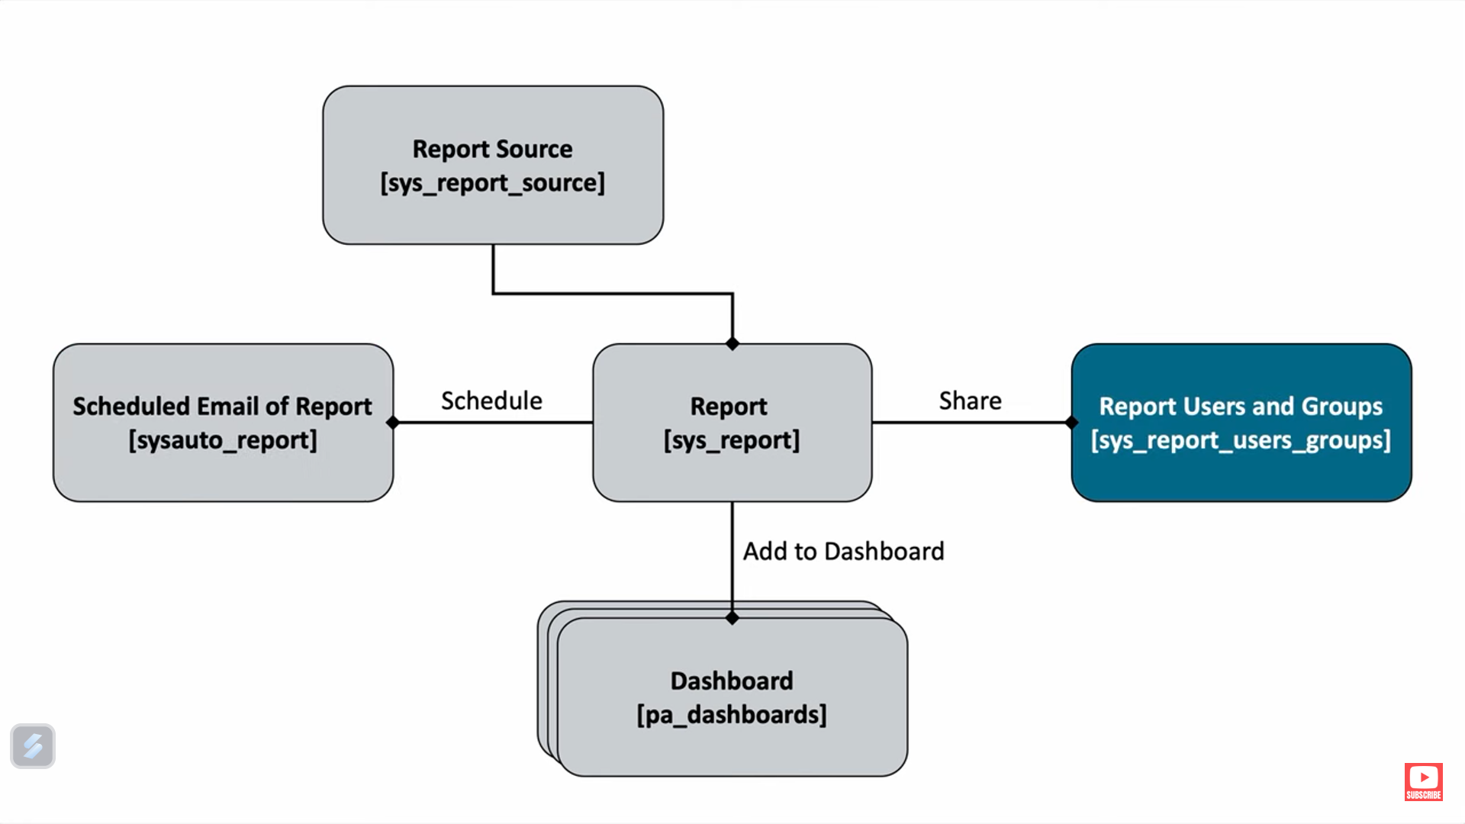

**Low Code/No Code Development**

* Top of Form
* Bottom of Form

LCNC means Low Code/No Code, meaning development with zero or very minimal manual coding. This offers a graphical user interface with drag-and-drop elements and pretrained templates to build software without demanding a deeper level of programming knowledge.  
  
How it Works  
Low Code: Very minimal coding is involved, yet one still needs programming experience to a certain extent. This is best for developers who want to speed up development by automating routine tasks and integrating custom code as required.  
No Code: Fully eliminates the use of codes. Users create applications by using visual interfaces and set templates, making it achievable to those with zero technical knowledge.  
Pros:  
  
Speed: The development is very fast compared to traditional coding techniques, thus enabling quick deployment of applications.  
Accessibility enables individuals without technical expertise to autonomously create and deploy applications.  
Economically Viable: It reduces the burden of hiring niche developers for relatively simple application projects, hence reducing development expenses.  
Flexibility: Allows quick adjustments and iterative development, hence equally quick modifications and updating.  
Cons  
  
Limited Customization: LCNC might not accommodate complex or highly tailored applications and may, therefore, be functionally limited.  
Scalability Issues: Applications developed on such platforms may face problems in scaling up to meet higher demands.  
Platform Dependency: Users might develop a dependence on particular platforms, which could constrain their long-term flexibility and adaptability.  
Security Challenges: Effective security measures seem to be very challenging to implement because of this limiting factor.  
Employment Opportunities  
  
Citizen developers are people who use no-code platforms to develop applications without having formal programming skills. Low-code developers are those who use low-code platforms to build more advanced applications by integrating custom code as needed. It involves training others and process optimization; platform specialists in LCNC platforms. Consultants: Advisers who support enterprises in selecting the right LCNC platforms and adopting best practices.

